EXP 8 – JOINS
Creating course table
Inserting values
1.INNER JOIN
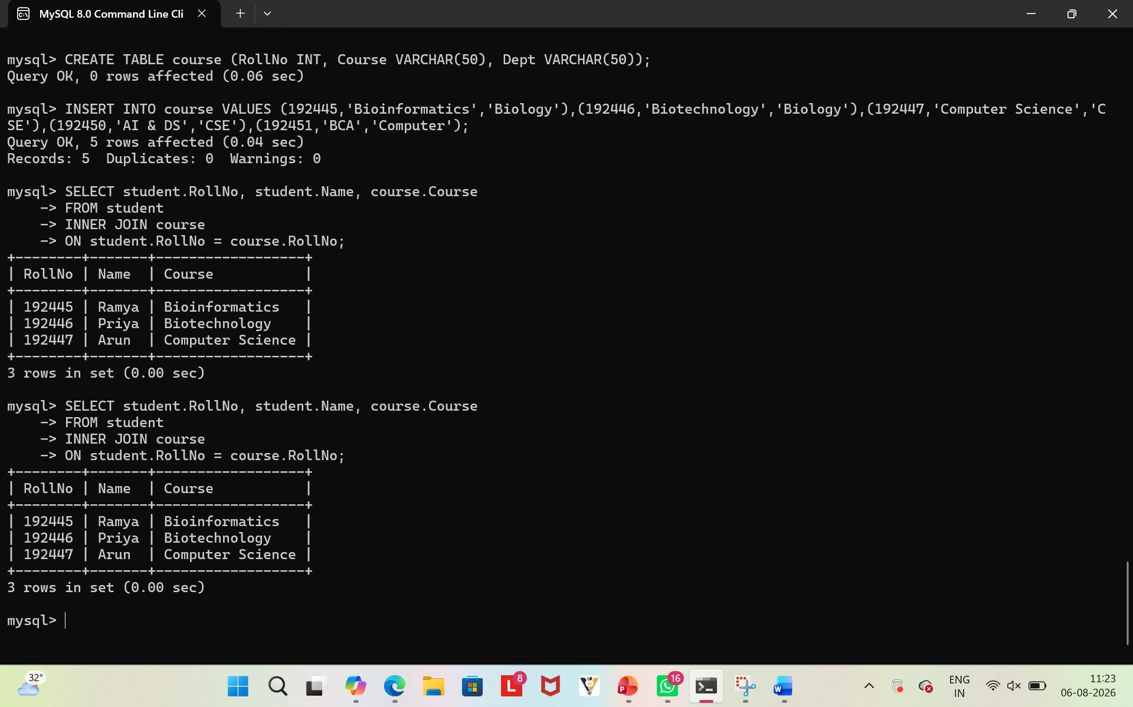
2.LEFT JOIN
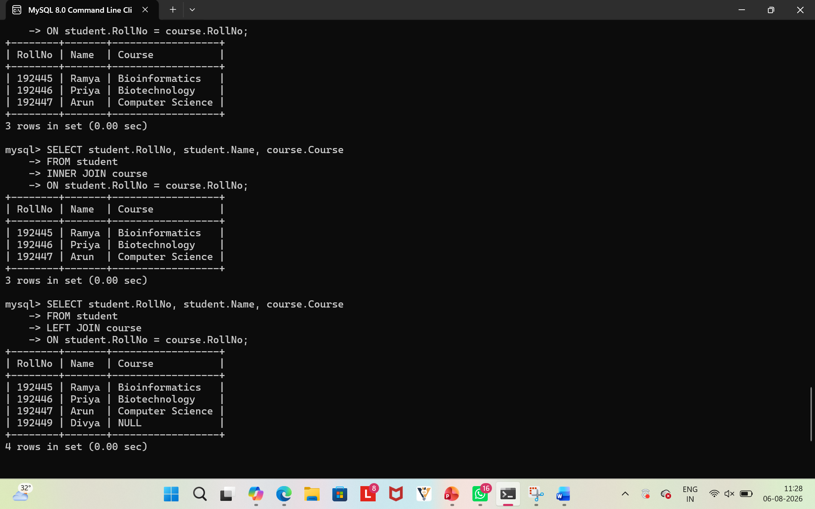

3.RIGHT JOIN
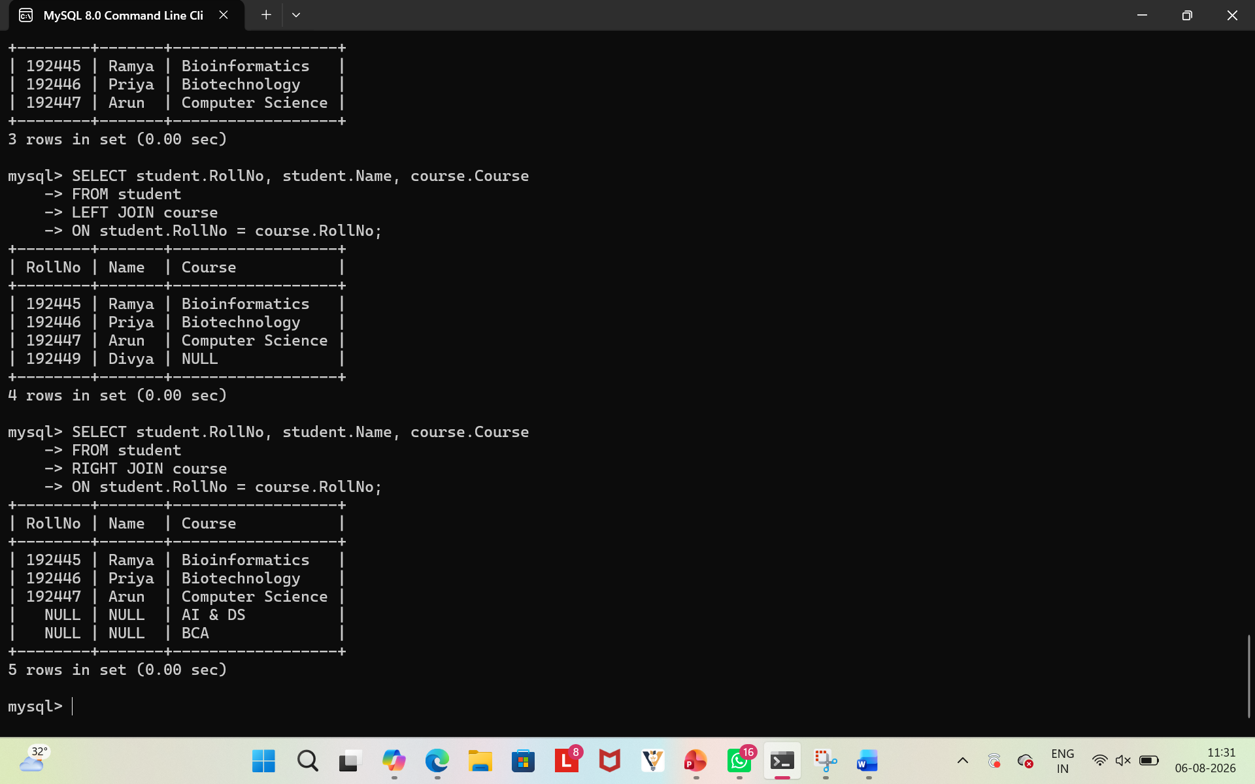
4.CROSS JOIN
